Name: kulsoom Alias Koonj

CMS ID: 023-20-0104

Lab 7

Activity 1

Code:

using System;

using System.Collections.Generic;

using System.ComponentModel;

using System.Data;

using System.Drawing;

using System.Linq;

using System.Text;

using System.Threading.Tasks;

using System.Windows.Forms;

namespace EditorApp

{

public partial class Notepad : Form

{

public Notepad()

{

InitializeComponent();

}

private void fileToolStripMenuItem_Click(object sender, EventArgs e)

{

}

private void newToolStripMenuItem_Click(object sender, EventArgs e)

{

richTextBox1.Clear();

}

private void openToolStripMenuItem_Click(object sender, EventArgs e)

{

OpenFileDialog dialogbox = new OpenFileDialog();

dialogbox.Title = "open";

dialogbox.Filter = "Text Document(*.txt)|*.txt | All Files (*.*)|*.*";

if(dialogbox.ShowDialog() == DialogResult.OK)

{

richTextBox1.LoadFile(dialogbox.FileName, RichTextBoxStreamType.PlainText);

this.Text = dialogbox.FileName;

}

}

private void saveToolStripMenuItem_Click(object sender, EventArgs e)

{

SaveFileDialog dialogbox = new SaveFileDialog();

dialogbox.Title = "Save";

dialogbox.Filter = "Text Document(*.txt)|*.txt| All Files (*.*)|*.*";

if(dialogbox.ShowDialog() == DialogResult.OK)

{

richTextBox1.SaveFile(dialogbox.FileName, RichTextBoxStreamType.PlainText);

this.Text = dialogbox.FileName;

}

}

private void exitToolStripMenuItem_Click(object sender, EventArgs e)

{

Application.Exit();

}

private void undoToolStripMenuItem_Click(object sender, EventArgs e)

{

richTextBox1.Undo();

}

private void redoToolStripMenuItem_Click(object sender, EventArgs e)

{

richTextBox1.Redo();

}

private void copyToolStripMenuItem_Click(object sender, EventArgs e)

{

richTextBox1.Copy();

}

private void cutToolStripMenuItem_Click(object sender, EventArgs e)

{

richTextBox1.Cut();

}

private void pasteToolStripMenuItem_Click(object sender, EventArgs e)

{

richTextBox1.Paste();

}

private void selectAllToolStripMenuItem_Click(object sender, EventArgs e)

{

richTextBox1.SelectAll();

}

private void fontToolStripMenuItem_Click(object sender, EventArgs e)

{

FontDialog test = new FontDialog();

if(test.ShowDialog() == DialogResult.OK)

{

richTextBox1.Font = test.Font;

}

}

private void foreColorToolStripMenuItem_Click(object sender, EventArgs e)

{

ColorDialog test = new ColorDialog();

if(test.ShowDialog() == DialogResult.OK)

{

richTextBox1.ForeColor = test.Color;

}

}

}

}

Output

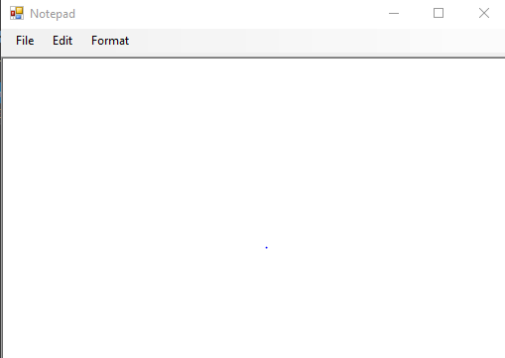

Activity 2:

Code:

using System;

using System.Collections.Generic;

using System.ComponentModel;

using System.Data;

using System.Drawing;

using System.Linq;

using System.Text;

using System.Threading.Tasks;

using System.Windows.Forms;

using System.Data.SqlClient;

namespace DatabaseApplication

{

public partial class Form1 : Form

{

public Form1()

{

InitializeComponent();

}

string connectionstring = @"Data Source=(localdb)\MSSQLLocalDB;Initial catalog=master;Integrated Security=True";

private void button1_Click(object sender, EventArgs e)

{

SqlConnection connection = new SqlConnection();

connection.ConnectionString = connectionstring;

connection.Open();

SqlCommand commands = new SqlCommand();

commands.Connection = connection;

commands.CommandText = @"SELECT *FROM Kulsoom ";

SqlDataReader datareader = commands.ExecuteReader();

textBox1.Text += "ID" + " " + "Name" + " " + "Password" + "\r\n";

while (datareader.Read())

{

String data = datareader.GetValue(0) + " " + datareader.GetValue(1) + " " + datareader.GetValue(2);

textBox1.Text += data + "\r\n";

}

}

private void textBox1_TextChanged(object sender, EventArgs e)

{

}

}

}

Output:

Activity 3:

Code:

using System;

using System.Collections.Generic;

using System.ComponentModel;

using System.Data;

using System.Drawing;

using System.Linq;

using System.Text;

using System.Threading.Tasks;

using System.Windows.Forms;

namespace WindowsFormsApplication18

{

public partial class Form1 : Form

{

public Form1()

{

InitializeComponent();

}

private person[] arr = new person[5];

private void Form1_Load(object sender, EventArgs e)

{

dataGridView1.AutoSizeColumnsMode = DataGridViewAutoSizeColumnsMode.Fill;

}

private void btnLoad_Click(object sender, EventArgs e)

{

arr[0] = new person("kulsoom", "Alias", "koonj");

arr[1] = new person("Humera", "Kulsoom", "Shaikh");

arr[2] = new person("Iqra", "Nadeem", "Shaikh");

arr[3] = new person("Sobia", "Kulsoom", "Shaikh");

arr[4] = new person("Sadia", "Inayat", "Shaikh");

dataGridView1.DataSource = arr;

}

public class person

{

String First_name;

String last_name;

String city;

public person() { }

public person(String First_name,

String last_name,

String city)

{

this.first_name = First_name;

this.Last_name = last_name;

this.City = city;

}

public string first_name

{

get

{

return First_name;

}

set

{

First_name = value;

}

}

public string Last_name

{

get { return last_name; }

set { last_name = value; }

}

public string City

{

get { return city; }

set { city = value; }

}

}

}

}

Output

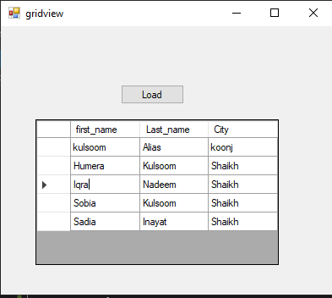

Activity 4

Code: